Angles and Lines
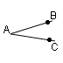
An angle is formed when two line segments intersect. The point of intersection is the vertex and the two lines form the sides of the angle. The angle is designated in a number of ways. It is BAC where the middle letter is the vertex, A where A is the vertex, or x where x is located inside the angle.
BAC

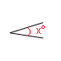
x

There are special kinds of angles:
A) Acute angles are less than 90 | 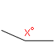  B) Obtuse angles are greater than 90
C) Right Angles are exactly 90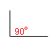 | D) Complementary Angles are two angles that sum to 90  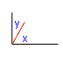
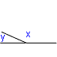
E) Supplementary Angles are two angles that sum to 180 (or a straight line).
Example 1
An incident ray strikes a flat surface and is reflected at the same angle. If the angle between the reflected ray and the incident ray is three times the angle of incidence, what is the angle of incidence?

Solution
The below sketch of the incident ray and the reflected ray is helpful.
If x is the angle of incidence, then x + x + 3x = 180, since a flat surface is a straight line of 180. Thus, 5x = 180, x = 36.
Intersecting Angles
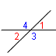
When two lines intersect, they form four angles: angles next to each other are supplementary angles, and angles opposite each other are vertical angles. Vertical angles are equal to each other. Adjacent angles have the same vertex and a common side. Note that in the following diagram angles 1 and 4, 2 and 4, 2 and 3, and 1 and 3 are adjacent angles.

1 =2
3 =4
1 + 4 = 180
2 + 4 = 180
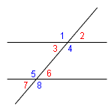
Two parallel lines never intersect. If a third line, a transversal, intersects two parallel lines, eight angles are formed. Corresponding angles are equal: 1 and 5, 2 and 6, 3 and 7, and 4 and 8. Alternate interior angles are equal: 3 and 6, and 4 and 5. The symbol || means "is parallel to."

1 = 5 = 4 = 8
3 = 6 = 2 = 7
3 + 4 = 180
4 + 6 = 180
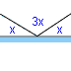
Two lines that intersect such that all four angles are equal are perpendicular, and all four angles are right angles. A small box in a corner indicates an angle of 90, a right angle. The symbol means "is perpendicular to": mn.
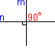
mn
Example 1
If the complement of an angle is one quarter of its supplement, what is the angle?
Solution
Let x be the angle.
Its complement y is y = 90 - x
Its supplement z is z = 180-x
If y = z/4, we have 90 - x = (180 - x)/4
multiply both sides by 4. 360 - 4x = 180 - x
180 = 3x, x = 60

Triangles
A triangle has three sides and three angles; the sum of its three angles is 180. There are three triangles that are particularly important to us: isosceles, equilateral and right. An isosceles triangle has two equal sides; the angles opposite the equal sides are also equal. All three sides of an equilateral triangle are equal; each of its three angles are 60. A right triangle is a triangle that has a 90 angle; the Pythagorean Theorem states that c = a + b , where c is its hypotenuse and a and b are its legs. The hypotenuse is always opposite the 90angle and the legs are always shorter than the hypotenuse.

Isosceles Triangle  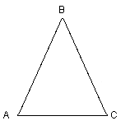  A = C | Equilateral Triangle  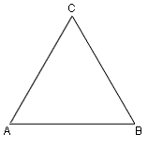  A = B = C = 60 | Right Triangle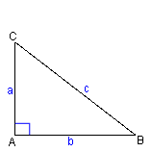  c = a + b  B + C = 90

There are certain right triangles that show up often on the test. The 3 - 4 - 5 triangle may be the most popular; note that the Pythagorean Theorem is satisfied since 5 = 3 + 4. The 5-12-13 triangle also surfaces occasionally. The second most popular triangle is the 30- 60- 90 triangle because the ratio of its short leg to its hypotenuse is 1 : 2. The 45- 45- 90 triangle has equal legs and is also encountered quite often. In the case of the 45- 45- 90 triangle, the length of each leg is times the hypotenuse; in other words, the hypotenuse is times one of the legs.
Commonly Used Triangles
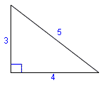  3 - 4 - 5 triangle | 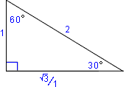  30- 60- 90 triangle
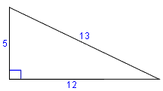  5-12-13 triangle | 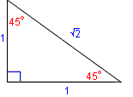  45- 45- 90 triangle

A triangle may not have the actual dimensions shown above, but may have a multiple of the dimensions. For example, if two legs of a right triangle have dimensions of 9 and 12, their ratio is 3:4, so the triangle is a 3 - 4 - 5 triangle but three times larger than the base triangle; the hypotenuse is 3 X 5 = 15.
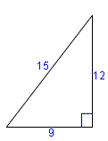
The hypotenuse of a 45- 45- 90triangle has dimensions larger than the legs, as shown below.
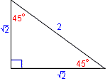
If the hypotenuse of a 30- 60- 90triangle has dimensions as shown below, the side opposite the 30 angle is 1/2 the length of the hypotenuse. The side opposite the 60 angle is / 2, multiplied by the hypotenuse.

800score.com Strategy: Always have memorized, it is 1.732 and the is 1.414. Why memorize these? Because when you are doing geometry questions you will often have to guess answers within rough paramerters. This may allow you to better guesstimate your answers. So lets say you know the answer to a given question is probably between 25 and 30, but you get 20. Now you can sub for 1.4 and get 28 (which fits your guesstimate).
Example 1
For the triangle shown, find L.
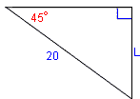

Solution
The small box in the corner signifies a right triangle. The ratio of the two legs is 12/16 = 3/4. It is a 3-4-5 triangle. It is 4 times the base 3-4-5 triangle; consequently, its hypotenuse L is L = 4 x 5 = 20.
Or we could have used the Pythagorean Theorem to obtain:
L= 12 + 16
L= 400
L = 20
Example 2
Calculate the length L for the triangle shown.

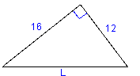

Solution
This is a right triangle, a 45- 45- 90 triangle. The length of a leg of such a triangle is times the hypotenuse. This gives
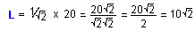

Example 3
A given isosceles triangle has two equal angles of 30. The side common to the 30 angles has a length of 4. How long are the equal sides?
Solution
A sketch of the triangle is always helpful. Let x be the unknown length. You know how to use the properties of a right triangle to solve for the sides of a triangle, so if you have to solve for the side of a different kind of triangle, you can use a right triangle within the given triangle. Can you see how one of the triangles we've just discussed could be helpful in solving the problem? By dividing the isosceles triangle into 2 right triangles, we get two 30- 60- 90triangles.
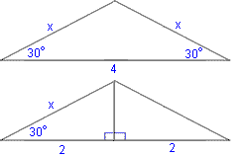
The ratio of the side adjacent to the 30 angle and the hypotenuse is . Hence,
Example 4
A triangle has angles of 45and 75 The side opposite the 45angle has a length of 6. What is the length of the side opposite the 75 angle?
Solution
Sketch the triangle. The remaining angle is 180 - (75 + 45) = 60. Again, see if you can solve the problem by creating right triangles. Form two right triangles and label the unknowns x, y, z. The side adjacent to the 60 angle is 1/2 the hypotenuse.
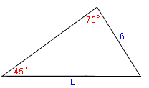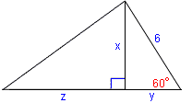
Hence, y = 3. The side opposite the 60 angle is x = 3 (the triangle is 3 times as big as the base 30- 60 - 90 triangle shown previously). Since the legs of a 45- 45- 90 triangle are equal, z = x = 3. The length is then

